The Problem with Traditional “Platform” Threads
A traditional thread in Java is essentially a thin wrapper around an operating system (OS) level thread. This means every time you create a Thread in your code, the Java Virtual Machine (JVM) requests the underlying OS to create a real thread.
Creating an OS thread is a relatively expensive operation because:
- Memory Allocation: The OS must allocate a significant block of memory on the stack for the thread.
- Context Switching: The OS kernel manages scheduling and context switching between different threads, which introduces overhead.
This model works fine for a small number of threads. However, modern web applications often need to handle a high degree of concurrency. In the traditional “one-thread-per-request” model used by web servers, each incoming HTTP request is handled by a dedicated thread. Under heavy load, the cost of creating and managing thousands of OS threads becomes a major bottleneck.

To mitigate this, Java applications have long relied on thread pools—a fixed number of pre-created OS threads that are shared and recycled to handle incoming tasks. While this helps, it doesn’t solve the core problem; you are still limited by the size of the pool.

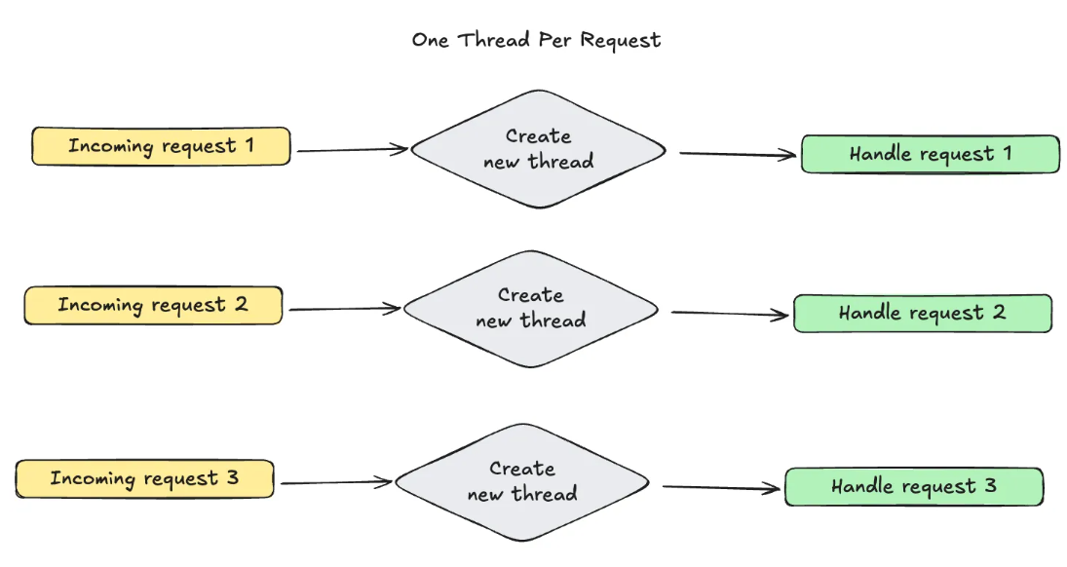

How Virtual Threads Work #
Virtual threads introduce a new model. They are lightweight threads managed entirely by the JVM, not the OS. This fundamental difference makes them far more efficient and scalable.
Here’s how it works:
- When you create a virtual thread, it does not create a new OS thread.
- The JVM maintains a small pool of OS threads, referred to as carrier threads.
- The JVM “mounts” a virtual thread onto a carrier thread to run its code. When the virtual thread performs a blocking I/O operation (like a database query or an API call), the JVM can “unmount” it, freeing up the carrier thread to run a different virtual thread.
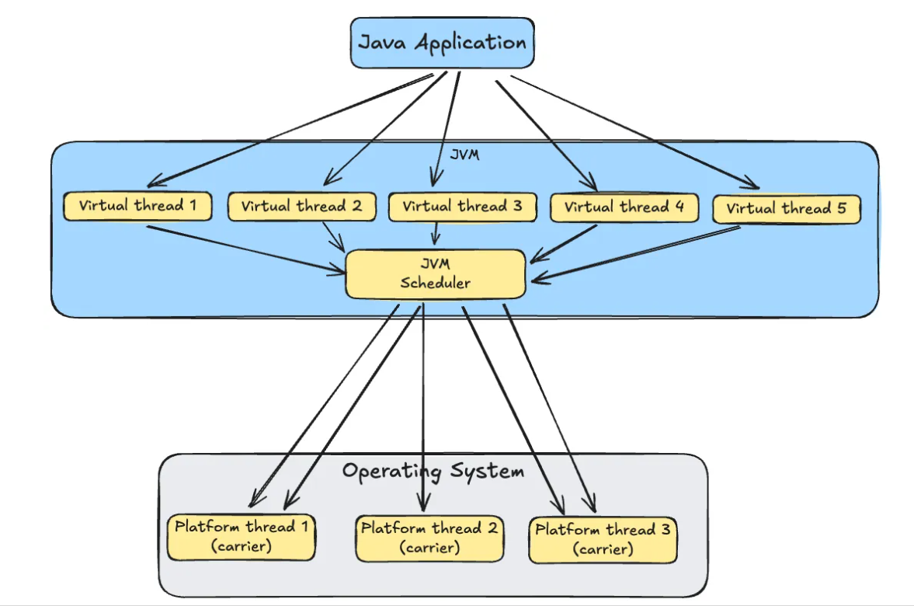

This scheduling mechanism allows a small number of OS carrier threads to handle millions of virtual threads, eliminating the overhead and limitations of the platform thread model.

Virtual threads can be enabled in your spring boot project using one of the following options:
- Setting property : spring.threads.virtual.enabled=true
- Java Config (custom executor) :
@Bean public TaskExecutor applicationTaskExecutor() {
return new ThreadPoolTaskExecutor() {{ setVirtualThreads(true); }}; }

This configuration automatically configures virtual threads for:
- Embedded Tomcat/Jetty
- @Async methods
- WebClient/Reactive stacks

We have used Apache benchmark to capture thread metrics:

Apache Benchmark on Windows

Apache Benchmark (ab) is a command-line tool for load testing HTTP servers. On Windows, it can be used to measure server performance under different request loads.
Installation
- Download Apache HTTP Server for Windows Get the latest binaries from Apache Lounge. Example: httpd-2.4.58-win64-VS17.zip.
- Extract Files Unzip and navigate to Apache24/bin.
- Locate Executables The benchmarking tool is ab.exe (and abs.exe). Optionally, copy them to your project directory for easier access.
Running a GET Request Test
Step 1: Open Command Prompt or PowerShell in the directory containing ab.exe. Step 2: Run:
ab -c 10 -n 20 http://localhost:8080/

- -c: Number of concurrent requests (here, 10).
- -n: Total number of requests (here, 20).
This will output metrics like Requests per second, Time per request, and Transfer rate.

Benchmark 1: Without Virtual Threads (Default Platform Threads)
First, we run the test with spring.threads.virtual.enabled=true commented.
We sent 4000 total requests 400 concurrent at a time.
App processed 94 requests per seconds and took 42 seconds total to process all requests.
We set thread to sleep for 2 seconds, and this process with platform threads took almost 4 seconds in each percentile.
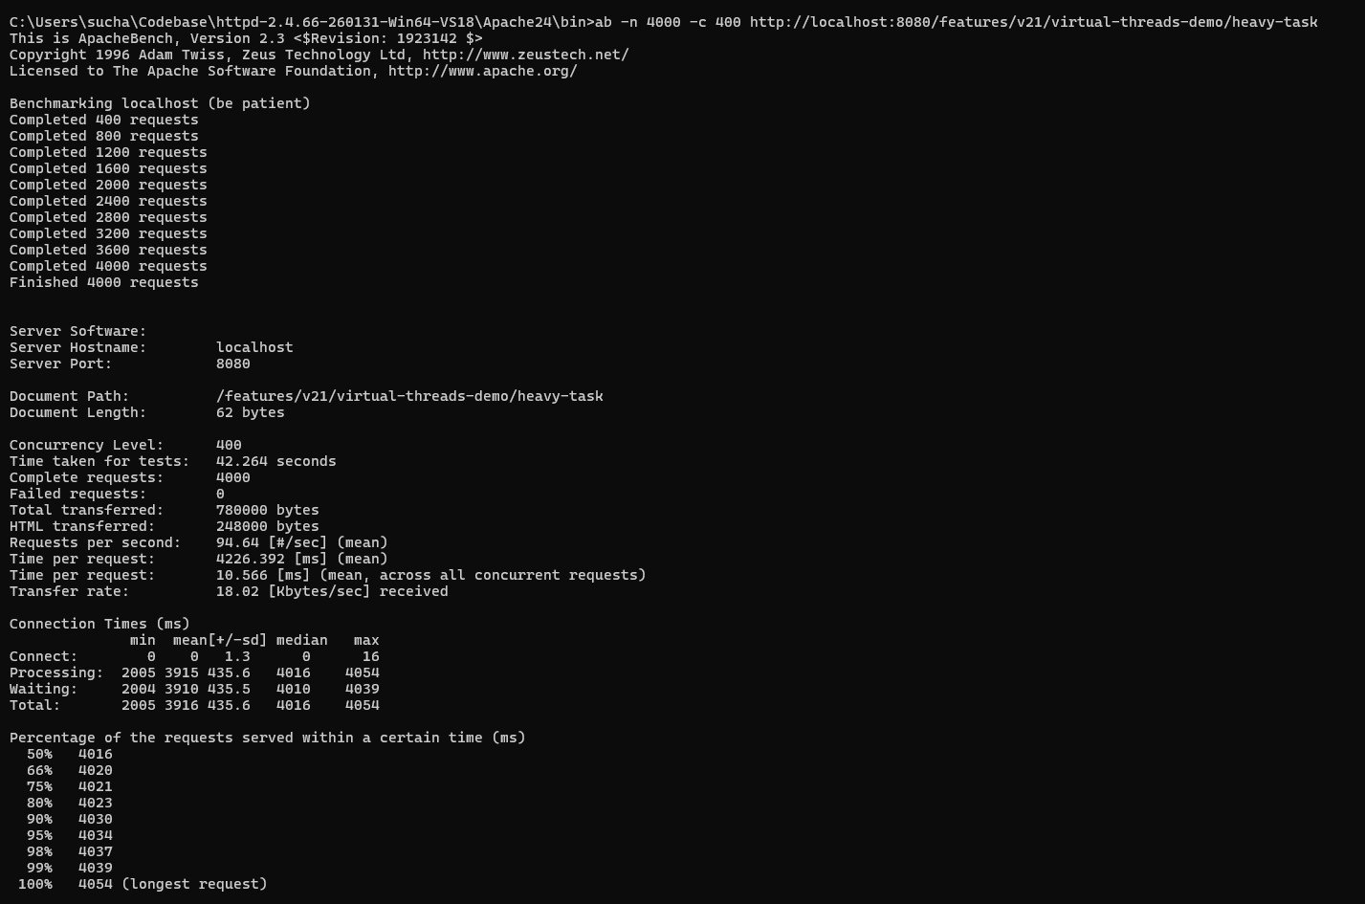

Benchmark 2: With Virtual Threads
We run the test with spring.threads.virtual.enabled=true.
We sent same 4000 total requests 400 concurrent at a time.
App processed 175 requests per seconds and took 22 seconds total to process all requests.
We set thread to sleep for 2 seconds, and this process with virtual threads took almost 2 seconds in each percentile.

The most telling metric is the percentile data. The response time remains consistently close to 2 seconds across the board, even at the 99th percentile. This is because the application could effortlessly create a new virtual thread for every concurrent request, handling the load without creating a bottleneck.

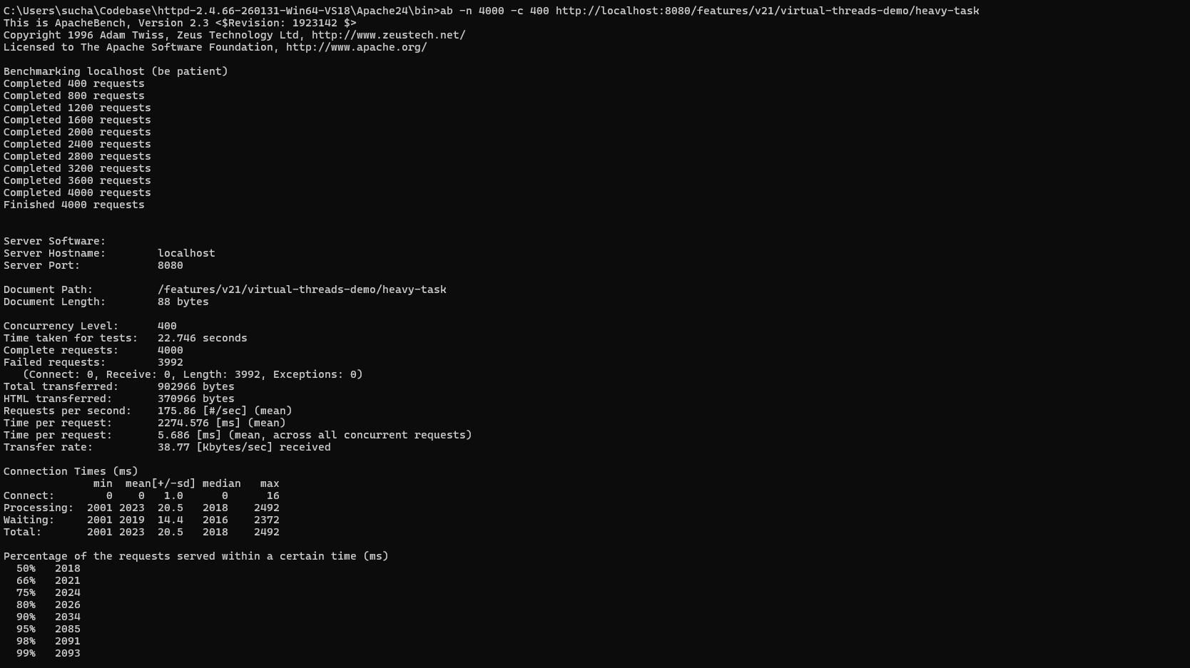

Virtual threads are good for:
- Avoid CPU-bound work in virtual threads: They’re ideal for I/O-heavy workloads.
- Use structured concurrency (Java 21 preview) to manage thread lifecycles.
- Profile your application to identify blocking points (e.g., JDBC calls).

Virtual threads may bot be suitable for:
- Not all libraries are virtual-thread friendly. Watch out for native synchronization primitives (synchronized, wait()).
- Connection pool exhaustion: You still need to tune database pools (or use R2DBC).
- Monitoring: Many observability tools don’t yet fully support virtual threads.

